[Date]

Daniel Ingram

CSC 340

Spring 2020

Personal Calendar System

Final Report

Contents

I. Introduction 1

A. Problem Statement 1

B. Proposal 1

II. System Description 1

III. System Requirements 1

A. Functional Requirements 1

B. Nonfunctional Requirements 7

IV. Use Case Diagram (1) 7

V. Class Diagram (1) 7

VI. Sequence Diagram (Many) 7

VII. Activity Diagram (Many) 7

VIII. State Diagram (1 for the whole system behavior) 8

IX. Database Design 9

X. Conclusion 9

XI. Data Dictionary 9

# Introduction

## Problem Statement

## Proposal

# System Description

# System Requirements

## Functional Requirements

* + 1. The system shall allow users to add a new event to their calendar
       1. The user shall select a day from the monthly calendar to add the new event. 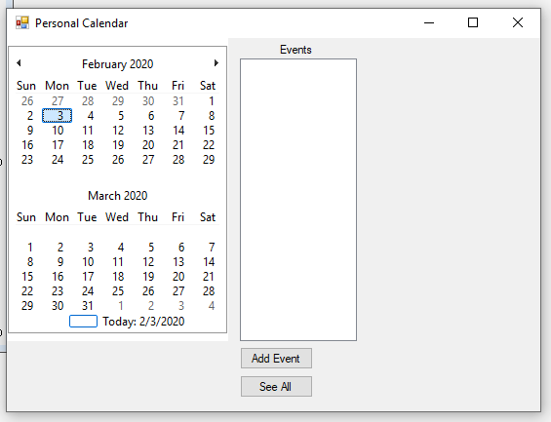
       2. The system shall highlight the selected date on the calendar.
       3. The user shall press the “Add Event” button. 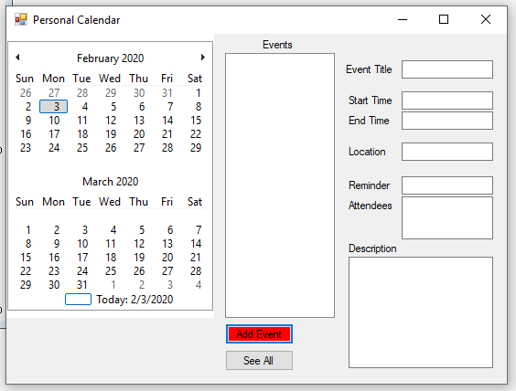
       4. The system shall display a form to allow the user to enter the information of the new event, including title, contents, start time, end time, reminder time, location, and attendees.
       5. The user shall enter the data for the event information and press the save button.

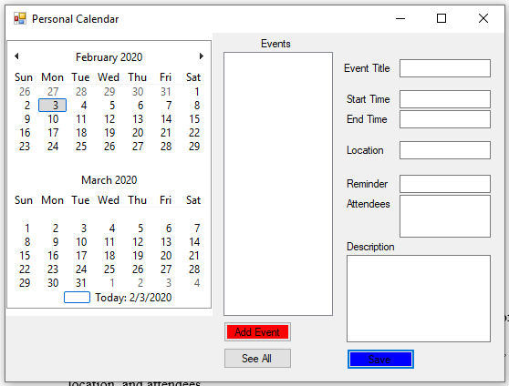

* + - * 1. The system shall check the contents of the new events with existing events.

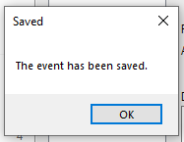

* + - 1. The system shall save the event to the database and display the event title on the calendar.
    1. The system shall allow the user to delete events from the calendar.
       1. The user shall select an event from the calendar.
       2. The system shall display event information.
          1. The system shall display a “Delete” button beneath the event information.

* + - 1. The user shall select the “delete event” button.

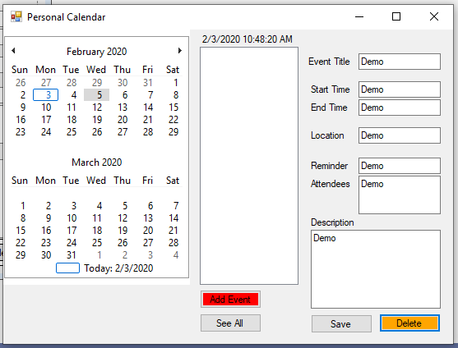

* + - 1. The system shall remove the event from the database.

R3. The system shall allow the user to edit an event

* 1. The user shall view an event

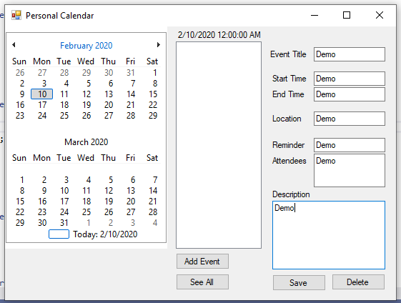

* 1. The user shall edit any of the event’s text fields.

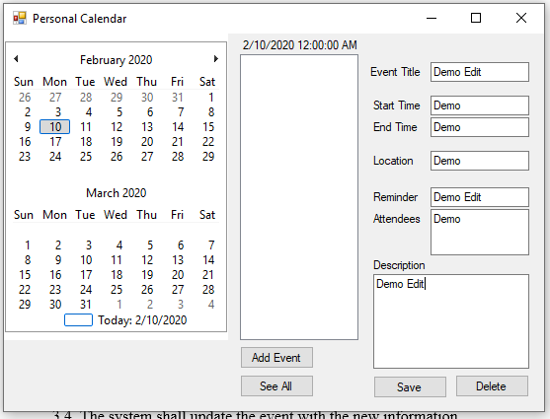

* 1. The user shall select the “save” button.

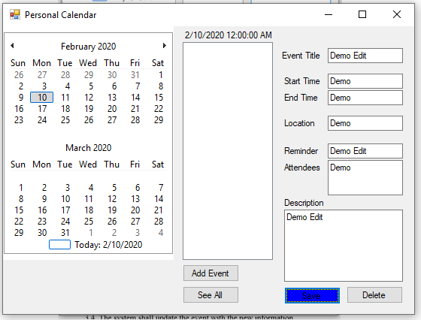

* 1. The system shall update the event with the new information.



R4. The system shall allow the user to view their saved events.

4.1. The user shall select a date on the calendar.

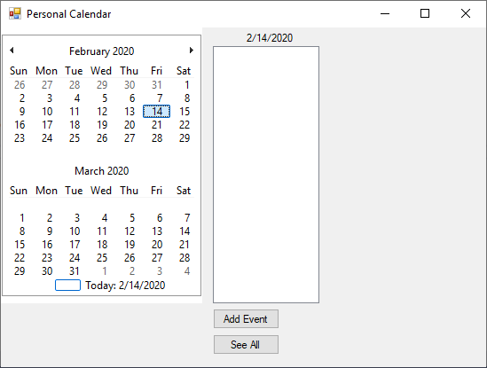

4.2. The system shall display all events on that day.

R5. The system shall allow the user to view a list of all the events in an entire month.

5.1. The user shall select “See All”.

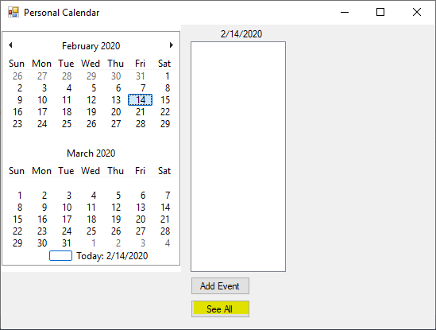

5.2 The system shall display all the events in the currently selected month.

## Nonfunctional Requirements

# Use Case Diagram (1)



Actions a user can take within the system.

# Class Diagram (1)



# Sequence Diagram (Many)

R1. The system shall allow users to add a new event to their calendar



R2. The system shall allow the user to delete events from the calendar.



R3. The system shall allow the user to edit an event



R4. The system shall allow the user to view their saved events.



R5. The system shall allow the user to view a list of all the events in an entire month.



# Activity Diagram (Many)

View Event:



addEvent()



Edit Event:



Delete Event:



View Monthly Events:



# Database Design



Event

|  |  |  |  |  |  |  |  |
| --- | --- | --- | --- | --- | --- | --- | --- |
| EventID | Title | StartTime | EndTime | Location | Description | Reminder | EmpID |

# State Diagram

State Diagram (1 for the whole system behavior)



# Conclusion

The calendar system detailed previously provides a calendar on which a user can create, edit, and remove events. The user can use this system to help with scheduling and keeping track of who needs to be where, and when.

# Data Dictionary

* System – The application installed on the user’s computer
* Conflict – An attendee is scheduled to be at two different events at the same time
* Database – Internet based storage space for the system to keep track of events without the user having to see them
* Field – Square of text that can be changed by the user